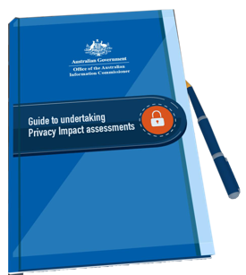
‘Your PIA’ worksheet
Use this worksheet while you work through the modules to fill in key information about your project. This will make it easier for you when you start your own PIA.

My project

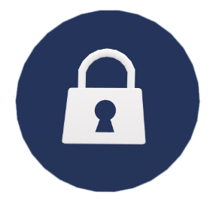
Topic 2

Threshold assessment

a) Will any personal information be collected, stored, used or disclosed as part of your project?
Remember that personal information does not always have to include details such as an individual’s name to qualify as personal information.

b) If yes, record the different types of personal information that will be handled.

c) If no, record the reasons for your decision

Topic 3

2. Plan

a) At what stage in your project do you intend to conduct your PIA?

b) Who will conduct your PIA?

c) What budget and other resources are available to conduct the PIA?

Describe

Write a brief description of your project

Identify and consult with stakeholders

List the stakeholders for your project, and indicate whether you will consult with all stakeholders, or undertake a targeted consultation

Internal

External

Topic 4

Map information flows

Draw a diagram that outlines the information flows in your project

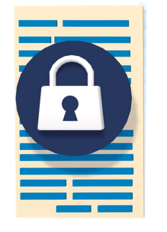
Topic 5

Privacy impact analysis and compliance check

a) List some of the positive privacy impacts of your project

b) List some of the negative privacy impacts of your project

c) Does your project comply with the APPs?
Remember to make a record of whether the APP is relevant to your project, whether your project complies, and whether there are any risks to compliance. You may also wish to consider likely community perceptions and expectations in relation to each APP.

APP 1 — open and transparent management of personal information

APP 2 — anonymity and pseudonymity

APP 3 — collection of solicited personal information

APP 4 — dealing with unsolicited personal information

APP 5 — notification of the collection of personal information

APP 6 — use or disclosure of personal information

APP 7 — direct marketing

APP 8 — cross-border disclosure of personal information

APP 9 — adoption, use or disclosure of government related identifiers

APP 10 — quality of personal information

APP 11 — security of personal information

APP 12 — access to personal information

APP 13 — correction of personal information

Topic 6

Privacy management — addressing risks

List the risks to privacy that you identified in your privacy impact analysis and compliance check. For each risk, list three options to remove, minimise or mitigate these privacy risks.

Privacy risk

Mitigation strategies

Privacy risk

Mitigation strategies

Privacy risk

Mitigation strategies

Privacy risk

Mitigation strategies

Privacy risk

Mitigation strategies

Privacy risk

Mitigation strategies

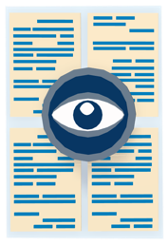

Topic 7

Recommendation

  - Consider the mitigation strategies you have listed above. Outline:
      - which mitigation strategy you recommend your organisation adopts to address each privacy risk
      - the individual or business area responsible for carrying out the recommended action
      - your suggested timeframe for implementation

Report

- List the stakeholders (internal and external) that you will circulate your final PIA report to
Remember that the OAIC strongly encourages the publication of PIA reports.

Topic 8

Respond and review

- Is it likely that you will need to revisit your PIA to update or revise it? Consider the length of your project and potential for changes to the project design or implementation.

Congratulations! Your PIA is now underway.
You can use the information that you have recorded here to finalise your PIA for your project.
The OAIC’s Guide to undertaking privacy impact assessments has more suggestions for other information you may want to include.

